COMMITTEE MEMBERS

CHAIRPERSON
Jesse H.
(901) 283-0541
jesmehill@gmail.com

ALT. CHAIRPERSON
Arnetta P.
(216) 801-5856
pryorarnetta@yahoo.com

SECRETARY
Karen S.
(216) 647-2377

ALT. SECRETARY
Denise H.
216-240-6337
denisehodges513@yahoo.com

TREASURER
Robert A.
216-242-7896
ausbrookenterprises@yahoo.com

ALT. TREASURER
Quinsetta M.
(216) 253-6315

ARCHIVIST
David E.
(216) 280-4269

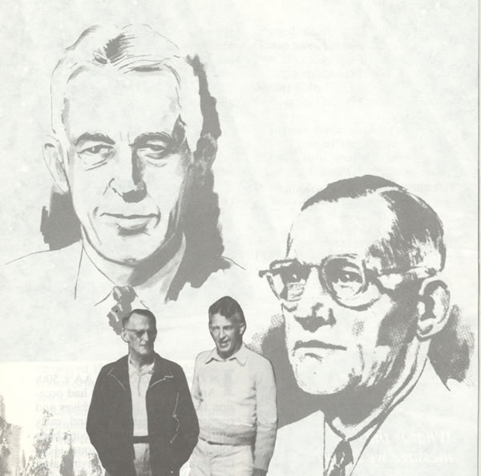
Cleveland North-Coast Multi- District Boundaries

29 Southern Border of Miles Rd., east to SOM Center (SR 91), north to Chagrin Blvd., west to East 116th St., south to Miles Rd. Includes Shaker, Warrensville, Woodmere,
Moreland Hills, Orange and North Randall.

31 East Cleveland.

33 East 30th at the Lake, south to Broadway, southeast to E. 79th St., north to the Lake.

34 Ontario at the Lake, South to Broadway, Southeast to East 30th, North to the Lake.

35 Area bounded by East 79th on the west, Euclid avenue on the south, Eddy Rd on the east, and Lake Erie on the north, including the Village of Bratenahl; excluding the
City of East Cleveland [District 31].

36 Within the City of Cleveland bounded by Lake Erie on the north, the Cuyahoga River on the east, Lorain Ave. on the south, and West Blvd. on the west.

38 City of Cleveland West of West Blvd.

45 Cleveland. South of Euclid Avenue; East of East 79th St.; West of East 116th St.; North of Broadway and Miles Avenue.

Responsibility Pledge
I am Responsible…
When Anyone, Anywhere
Reaches Out For Help,
I Want The Hand Of A.A.
Always To Be There. And For That,
I Am Responsible!

Declaration of Unity

This we owe to A.A.'s future:
To place our common welfare first;
To keep our fellowship united.
For on A.A. unity depend our lives,
And the lives of those to come.

2015 CLEVELAND NORTH COAST MULTI –DISTRICT SCHEDULE

January 3 – Monthly Meeting

February 7 – Monthly Meeting

March 7 – Monthly Meeting

April 4 – Monthly Meeting

May 2 – Monthly Meeting

May 16- Workshop

June 6 – Monthly Meeting

July 11 – Monthly Meeting

August 1 – Monthly Meeting

August 15 – Multi-District Picnic

September 6 – Monthly Meeting

October 3 – Monthly Meeting

October 17 - Workshop

November 7 – Monthly Meeting
(Elections)

December 5 – Monthly Meeting

Unless otherwise noted, Cleveland North Coast Multi-District meetings are held on the 1st Saturday of every month at the Carl B Stokes Building 6001 Woodland Avenue Cleveland 44120 from 12 noon to 2:00 P.M.

2015 Area Events
January 18 – Area Assembly Gv Lit
January 25 – Mini-Conf planning meeting Doubletree Hotel - Independence – 2pm (If inclement weather, then March 15th)
February 15 – GSR School Workshop
February 22 – Mini-Conf planning meeting
Doubletree Hotel – Independence – 2pm
March 15 – Area Assembly (and MC planning snow date)
March 27-29 – 40th NEOH Mini-Conference
Doubletree Hotel – Independence Gv Lit
April 19 – Area Assembly
May 17 – Unity Day Workshop Lit
June 12-14 – Founders’ Day Gv (Grapevine sales on Saturday only)
June 21 – Area Open House Picnic
July 19 – Area Assembly Gv Lit
August 16 – Workshop DCM College
September 20 - Area Assembly
October 18 - Assembly Gv Lit (Area Elections)
November 22 - Gratitude Sunday Gv Lit (TBA)

Gv = Grapevine sale days
Lit = Literature sale days
.
Statewide, regional and national events of interest outside the area include:
February 13-15 – Bay City, MI
42nd Conference of Delegates, Past and Present
March 6-8 – Deer Creek Lodge - Mt Sterling, OH
Area 53 Mini-Conference
March 13-15 – Perrysburg, OH
Area 55 Mini-Conference
March 20-22 - Dayton, OH
Area 56 Mini-Conference
April 19-25 – New York, NY
65th General Service Conference
May 2 – Columbus, OH
Ohio State Convention Planning Meeting
July 2-5 – Atlanta, GA
International Convention of AA.
August 7-9 – Cincinnati, OH
59th Ohio State Convention
September 24-27 – Independence, OH
Nation Archives Workshop
November 7 – Columbus, OH
Ohio State Convention Planning Meeting
November 13-15 – Milwaukee, WI
East Central Regional Forum

CLEVELAND NORTH COAST
MULTI –DISTRICT
Area 54
Districts 29, 31, 33, 34, 35, 36, 38 and 45

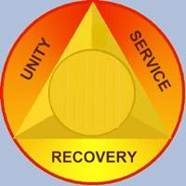

“Alcoholics Anonymous” is a fellowship of men and women who share their experience, strength and hope with each other that they may solve their common problem and help others to recover from alcoholism.
The only requirement for membership is a desire to stop drinking. There are no dues or fees for A.A. membership; we are self-supporting through our own contributions.
A.A. is not allied with any sect, denomination, politics, organization or institution; does not wish to engage in any controversy; neither endorses nor opposes any causes.

Our primary purpose is to stay sober and help other alcoholics achieve sobriety.
Copyright © by The A.A. Grapevine, Inc.

