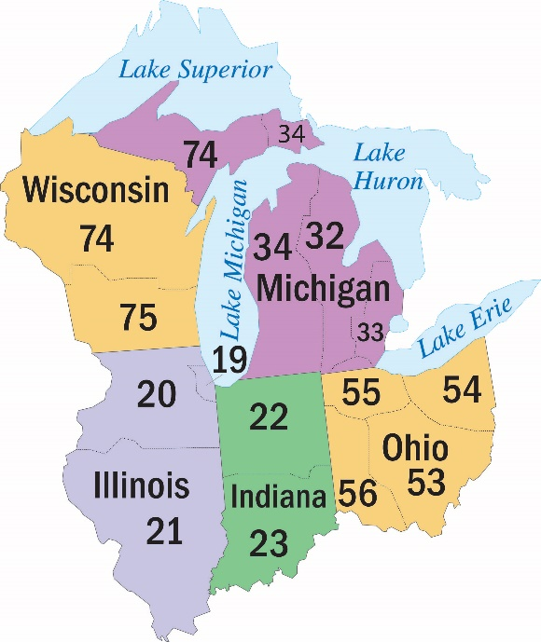
44th Annual East Central Region
Conference of Delegates Past and Present
February 9 – 11, 2018

Embassy Suites by Hilton Indianapolis North
3912 Vincennes Road
Indianapolis, IN 46268
317-872-7700
(Mention East Central Region when making reservations)

Room Rate: $139 plus tax per night,
Single or Double
(includes hot breakfast and evening hors d’oeuvres)

Reservation deadline for CDPP rate: January 20, 2018
To register, please complete registration form below and mail to:

Southern Indiana Area Committee - CDPP
PO Box 546
Indianapolis, IN 46206

Contacts: Charlotte C. 317-417-1662 or Cathi C. 317-246-7953
_________________________________________________________________________________________________
44th Annual CDPP Registration Form

NAME __________________________________________________ FULL NAME ON BADGE(Y/N)? ____
PARTNER* _______________________________________________ FULL NAME ON BADGE(Y/N)? ____
ADDRESS ________________________________________________________________________________
CITY_________________________________________ STATE__________________________ ZIP__________
PHONE ______________________________________ EMAIL _____________________________________
CHECK ONE: TRUSTEE/PAST TRUSTEE____ DELEGATE____ PAST DELEGATE____ ALTERNATE DELEGATE____
AREA OFFICER____ DCM____ GSR____ OTHER____ AREA ______ PANEL ______
ACCESSIBILITY REQUESTS ___________________________________________________________________________
Registration(s) *(no registration fee for non-AA guests) #________ x $25.00 = $_________
Meal Package (Saturday Lunch & Banquet) #________ x $50.00 = $__________
Saturday Banquet only #________ x $35.00 = $__________
(select banquet entrée at registration) Total $________
Please make checks payable to:
Southern Indiana Area Committee – CDPP
PO Box 546, Indianapolis, IN 46206

