44th ANNUAL

AREA 54 NORTHEAST OHIO GENERAL SERVICE


MINI-CONFERENCE

March 29 - 31, 2019

“Our Big Book -- 80 Years, 71 Languages”

All MEMBERS of A.A. are encouraged to attend this conference!

SCHEDULE

Friday –
- History of Mini-Conference

Introductions
- General Sharing Session

Saturday –
- Early-Bird A.A. meeting
- Conference Committee Sessions
- Presentations of Committee Reports
- Voting on Agenda Items
- Banquet, Skit & Speaker Meeting

Sunday –
- Early Bird A.A. Meeting
- Panel Discussions
- Ask-It Basket
SPEAKERS  Banquet  (Open AA Meeting)  Patrick C  GSO Staff  Trustee’s Report  .  Registration  Friday: 2 – 7 PM  Saturday: 8 – Noon  Hospitality Suite  Opens Friday at 4 PM  Conference Begins  Friday: 7:00 PM  Come Have Your Group’s Voice Heard in New York |  |  |  | LOCATION  Doubletree by Hilton Westlake  1100 Crocker Rd Road  Westlake, Ohio 44145  Tel: 440-871-6000  $109 per night  (Plus State & Local Tax)  Includes Complimentary Breakfast Buffet  Reserve your room by  March 5, 2019  Ref: Northeast Ohio Mini-Conference  Free parking for hotel guests and local participants  Handicap Accessible  For More Information Contact  Jamie B. 216-548-5410  Shyrl B. 216-702-0572

Register and pay online AT www. http://area54.org
CONFERENCE REGISTRATION 2019
NAME _______________________ As you would like it on your name badge __________________________________
ADDRESS________________________________________________________________________________________CITY_____________________________________STATE ________ZIP __________PHONE _____________________
Registration ______ x $25.00 = $ ________
Saturday (Buffet) Banquet ______ x $35.00 = $ ________ Request for Special Needs______________________
(Banquet prepaid only) Total = $ ________ _________________________________________
Please make checks payable to NE Ohio Mini-Conference
Mail to Area 54 Mini-Conference, PO Box 91384, Cleveland, OH 44101-3384
Email inquiries to: MiniConference@area54.org
Postmark No Later MARCH 18, 2019 to guarantee a banquet OR by PayPal for registration ONLY until 3/27/19 OR register in person at the Conference Registration until Sat at 1 pm (no banquet reserved after 3-18-2019)
Revised 11-27-18

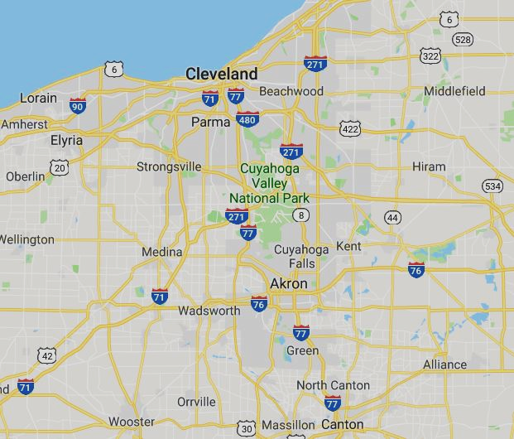
N
Directions To Doubletree by Hilton Westlake

From Erie and Points North East: Take I-90 West to Cleveland. Take I-90 West to Crocker Rd in Westlake. Take exit 156 from I-90 at Crocker Rd toward Bassett Rd. Use the 2nd from the right lane to turn right onto Crocker Rd. Turn at next left onto Clemens Rd. Turn at first right. The hotel will be on your left.

From Downtown Cleveland: Follow I-90 West. Take I-90 West to Crocker Rd in Westlake. Take exit 156 from I-90 at Crocker Rd toward Bassett Rd. Use the 2nd from the right lane to turn right onto Crocker Rd. Turn at next left onto Clemens Rd. Turn at first right. The hotel will be on your left.

From Youngstown or Pittsburgh PA and Points East: Continue on I-680 N. Take I-80 West, I-77 North. Follow I-77 North to I-490 West to I-90 West. Take I-90 West to Crocker Rd in Westlake. Take exit 156 from I-90 at Crocker Rd toward Bassett Rd. Use the 2nd from the right lane to turn right onto Crocker Rd. Turn at next left onto Clemens Rd. Turn at first right. The hotel will be on your left.

From Toledo and Points West: Take I-90 East toward Cleveland. Follow I-90 East to Crocker Rd in Westlake. Take exit 156 from I-90 for Crocker Rd toward Bassett Rd. Turn left onto Crocker Rd. Turn left onto Clemens Rd. Turn at first right. The hotel will be on your left.

From Cincinnati, Columbus, and Points South: Take I-71 North toward Cleveland. Follow I-71 north to Exit 240. Take exit 240 for West 150th Street. Use the left 2 lanes to turn left onto W 150th St for 2.1 miles. For .2 mi. Turn left onto Alger Rd for .3 miles. Turn left onto the I-90 West ramp to Toledo. Take Exit 156 for Crocker Rd toward Bassett Rd. Use the 2nd from the right lane to turn right onto Crocker Rd. Turn at next left onto Clemens Rd. Turn at first right. The hotel will be on your left.

From Dayton Take I-70 East to Columbus. Take I-270 to I-71 North towards Cleveland. Follow I-71 North to Exit 240. Take exit 240 for West 150th Street. Use the left 2 lanes to turn left onto W 150th St for 2.1 miles. For .2 mi. Turn left onto Alger Rd for .3 miles. Turn left onto the I-90 West ramp to Toledo. Take Exit 156 for Crocker Rd toward Bassett Rd. Use the 2nd from the right lane to turn right onto Crocker Rd. Turn at next left onto Clemens Rd. Turn at first right. The hotel will be on your left.

What is the purpose of the Area 54 Mini-Conference?
This Mini-Conference was developed to give our Delegate the informed conscience of the groups in Area 54—Northeast Ohio - on some of the agenda items that will be addressed at the General Service Conference. Due to time constraints, it is not possible to address all of the agenda of the General Service Conference. The selected agenda is mailed to the registered General Service Representatives (GSRs) of the groups in advance. The group can discuss the issues and send their group’s conscience to the Mini-Conference via their GSR. At the Mini-Conference the issues are discussed with GSRs from many groups throughout Area 54. Using the committee system and voting procedures described in the AA Service Manual, a consensus is reached. This consensus is taken to the General Service Conference by our delegate, who still maintains the right of decision described in the Twelve Concepts.
The Mini-Conference will also feature displays and information provided by the Area 54 Standing Committees and a variety of ways for a GSR to share with others committed to their service to others. GSRs can meet a General Service Board trustee, a staff member from the General Service Office and the Area Committee. There are also sharing sessions for GSRs and an Ask-it-basket hosted by past delegates, the trustee and GSO staff member.
Why do I have to pay?
While there are no dues or fees for membership in AA, it is the practice of Area 54 General Service that each individual event be self-supporting. This conference requires months of planning, preparation and money to present. Our expenses include printing of the background material and purchase of literature relevant to the agenda that will be discussed, printing of flyers and schedules, mailing costs and registration supplies. We do not pay our speakers, but we do provide for their expenses to attend the conference. At times we have snack or beverage expenses. The hospitality rooms are self-supporting of themselves. The Saturday Night Speaker is an open A.A. Meeting and is the only function that will not require attendees to be registered.

All members of A.A. are encouraged to attend!
Name badges must be worn at all times!

