43rd ANNUAL

AREA 54 NORTHEAST OHIO GENERAL SERVICE


MINI-CONFERENCE

March 23-25, 2018

“AA – A Solution for All Generations”

All MEMBERS of A.A. are encouraged to attend this conference!

SCHEDULE

Friday –
- History of Mini-Conference

Introductions
- General Sharing Session

Saturday –
- Early-Bird A.A. meeting
- Conference Committee Sessions
- Presentations of Committee Reports
- Voting on Agenda Items
- Banquet, Skit & Speaker Meeting

Sunday –
- Early Bird A.A. Meeting
- Panel Discussions
- Ask-It Basket
SPEAKERS  Banquet  (Open AA Meeting)  Steve Smith  GSO Staff  .  Trustee’s Report  .  Registration  Friday: 2 – 7 PM  Saturday: 8 – Noon  Hospitality Suite  Opens Friday at 4 PM  Conference Begins  Friday: 7:00 PM  Come Have Your Group’s Voice Heard in New York |  |  |  | LOCATION  Holiday Inn  15471 Royalton Road  Strongsville, Ohio 44136  Tel: 440-238-8800  $99 per night  (Plus State & Local Tax)  Includes Complimentary Breakfast Buffet  Reserve your room by  February 20, 2018  Ref: Northeast Ohio Mini-Conference  Free parking for hotel guests and local participants  Handicap Accessible  For More Information Contact  Jamie B. 216-548-5410  Shyrl B. 216-702-0572

VISIT US ONLINE AT http://area54.org
CONFERENCE REGISTRATION 2018
NAME _______________________ As you would like it on your name badge __________________________________
ADDRESS________________________________________________________________________________________CITY_____________________________________STATE ________ZIP __________PHONE _____________________
Registration ______ x $20.00 = $ ________
Saturday (Buffet) Banquet ______ x $35.00 = $ ________ Request for Special Needs______________________
(Banquet prepaid only) Total = $ ________ _________________________________________

Please make checks payable to NE Ohio Mini-Conference
Mail to Area 54 Mini-Conference, PO Box 91384 44101-3384
Email inquiries to: MiniConference@area54.org
POSTMARK NO LATER FEBRUARY 24, 2018 or register at the Conference Revised 12-13-17

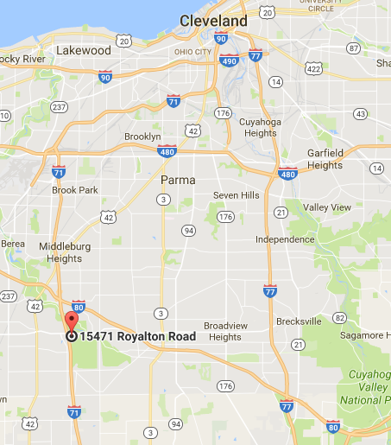
Directions

From Erie and Points North East: Take I-90 West to I-71 South. Follow I-71 South to the Royalton Rd/State Route 82 exit #231A. Turn Right (eastbound) onto Royalton Rd. The hotel will be on your right.

From Downtown Cleveland: Follow I-71 South to the Royalton Rd/State Route 82 exit #231A. Turn Right (eastbound) onto Royalton Rd. The hotel will be on your right.

From Youngstown or Pittsburgh PA and Points East: Take the Ohio Turnpike (I-80) West to I-71 South. Follow I-71 South to the Royalton Rd/State Route 82 exit #231A. Turn Right (eastbound) onto Royalton Rd. The hotel will be on your right.

From Toledo and Points West: Take the Ohio Turnpike (I-80) East to I-71 South. Follow I-71 South to the Royalton Rd/State Route 82 exit #231A. Turn Right (eastbound) onto Royalton Rd. The hotel will be on your right.

From Cincinnati, Columbus, and Points South: Take I-71 North toward Cleveland. Follow I-71 north to the Royalton Rd/State Route 82 exit #231. Turn right (eastbound) onto Royalton Rd. The hotel will be on your right.

From Dayton Take I-70 East to Columbus. Take I-270 to I-71 North towards Cleveland. Follow I-71 North to the Royalton Rd/State Route 82 exit #231. Turn right (eastbound) onto Royalton Rd. The hotel will be on your right.

Holiday Inn - Strongsville
15471 Royalton Road
Strongsville,OH 44136 Tel: (440)-238-8800

What is the purpose of the Area 54 Mini-Conference?
This Mini-Conference was developed to give our Delegate the informed conscience of the groups in Area 54—Northeast Ohio - on some of the agenda items that will be addressed at the General Service Conference. Due to time constraints, it is not possible to address all of the agenda of the General Service Conference. The selected agenda is mailed to the registered General Service Representatives (GSRs) of the groups in advance. The group can discuss the issues and send their group’s conscience to the Mini-Conference via their GSR. At the Mini-Conference the issues are discussed with GSRs from many groups throughout Area 54. Using the committee system and voting procedures described in the AA Service Manual, a consensus is reached. This consensus is taken to the General Service Conference by our delegate, who still maintains the right of decision described in the Twelve Concepts.
The Mini-Conference will also feature displays and information provided by the Area 54 Standing Committees and a variety of ways for a GSR to share with others committed to their service to others. GSRs can meet a General Service Board trustee, a staff member from the General Service Office and the Area Committee. There are also sharing sessions for GSRs and an Ask-it-basket hosted by past delegates, the trustee and GSO staff member.
Why do I have to pay?
While there are no dues or fees for membership in AA, it is the practice of Area 54 General Service that each individual event be self-supporting. This conference requires months of planning, preparation and money to present. Our expenses include printing of the background material and purchase of literature relevant to the agenda that will be discussed, printing of flyers and schedules, mailing costs and registration supplies. We do not pay our speakers, but we do provide for their expenses to attend the conference. At times we have snack or beverage expenses. The hospitality rooms are self-supporting of themselves. The Saturday Night Speaker is an open A.A. Meeting and is the only function that will not require attendees to be registered.

All members of A.A. are encouraged to attend!
Name badges must be worn at all times!

