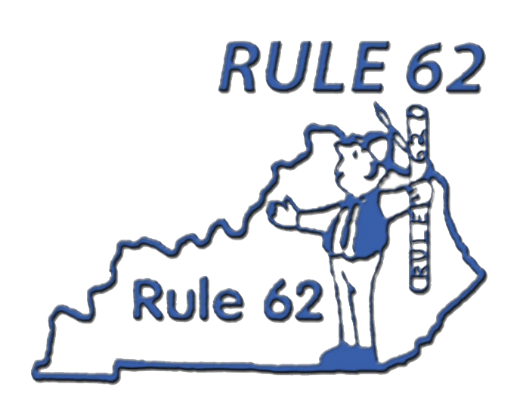Don’t take yourself too damn seriously

“Yes, All OF These Things Are Possible.”
12 Steps and 12 Traditions, page 112

August 3-5, 2018
Cincinnati Marriot Airport
1-minute drive from Interstate 275 Exit 4A at 2395 Progress Drive, Hebron, KY 41048
Standard Rm: $109.00 +tax Hotel Registration ends 7/20/2018. Book early! Conference registration does not guarantee a room. 859-586-0166
Friday: 7:00 pm Garry P. – Louisville, KY
9:00 pm Doug R. – Tujunga, CA

Saturday: 9:30 am John C. – Dayton, OH
11:00 am Ronda B. – Cincinnati, OH (AL-ANON)

1:00 pm Women’s panel Open to women and men!
2:30 pm Old Timer’s Panel
4:00 pm New Timer’s Panel

7:00 pm Carla R. – Tujunga, CA
8:30 pm Earl H. – Scottsdale, AR

Sunday: 9:30 am Diane S. – Erlanger, KY

Friday night entertainment – Open Mic / Talent Show!
Saturday night entertainment dance – DJ Wayne!

Pre-registration is $20.00 in advance or $25.00 at the door.
Please make checks payable to “Rule 62” P.O. Box 91, Hebron, KY 41048
Scholarships Available for Treatment Center Residents only (Does not apply to Sober Living)
Scholarships are available through the generosity of others. Please give to Scholarship Fund

Rule 62 T-Shirts Available at conference – Limited Supply

Questions or Comments Contact: Dave B. 513-207-4930 or Steve P. 513-310-9278

Go to rule62.eventsmart.com - -and use your credit card!-

-------------------Cut Here to Mail your check or money order ----------------
Make Payable to: “RULE 62” and Mail to: PO BOX 91, Hebron, KY 41048
$20.00 Pre-Registration. Mail-in registration must be received by July 31, 2018 or pay $25.00 at the door

Full Name(s) _________________________________________________________________________

Name(s) on Badge_____________________________________________________________________

Address______________________________________________________________________________

City_____________________________________________State____________Zip_________________

Email/Phone_______________________________ Number of registrations_________ Sponsorship Donation ______________________ Amount Enclosed __________

